In the event of a concussion

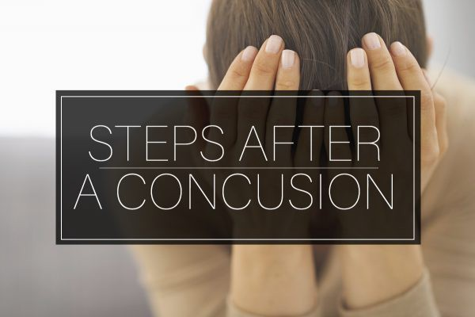

- Use the FirstResponder Concussion App on the sidelines in the event of a head impact

- See a medical doctor as soon as possible

- Complete post-concussion computerised testing by contacting support@headsmart.me

- When symptoms have settled, phase back into
school/study commitments using Cognitive Rehabilitation Form

- Start a light exercise programme co-ordinated by your physio or trainer using Exercise Rehabilitation Form

- Have medical clearance from a medical doctor to start contact training

All Rights Reserved ©2012-2017 HeadSmart™ Sports Concussion Programme ABN 93155451317

